Name: Sapargali Temirlan
Group: SE-2403
Instructor: Aigul Adamova
PART 2
PART A
1, 2. Contract Code:
(See HelloWorld.sol in Part 2 Folder)
3. Demonstrate:
getGreeting() – public; updateGreeting() – public; _privateHelper() – private; showPrivateMessage() – public
State persistence:
Initial state of the greeting is set by the constructor, after that it can be retrieved using getGreeting() or updated by updateGreeting().
For example: initial constructor(“Hello, Temirlan”), getGreeting() returns “Hello, Temirlan), getGreeting() after updateGreeting(“Hello, Remix”) returns “Hello, Remix”).
Gas usage comparison:
Public functions that return state do not consume any gas, while state changing functions such as “updateGreeting()” consumes gas, as you need to modify all blocks.
Submissions:
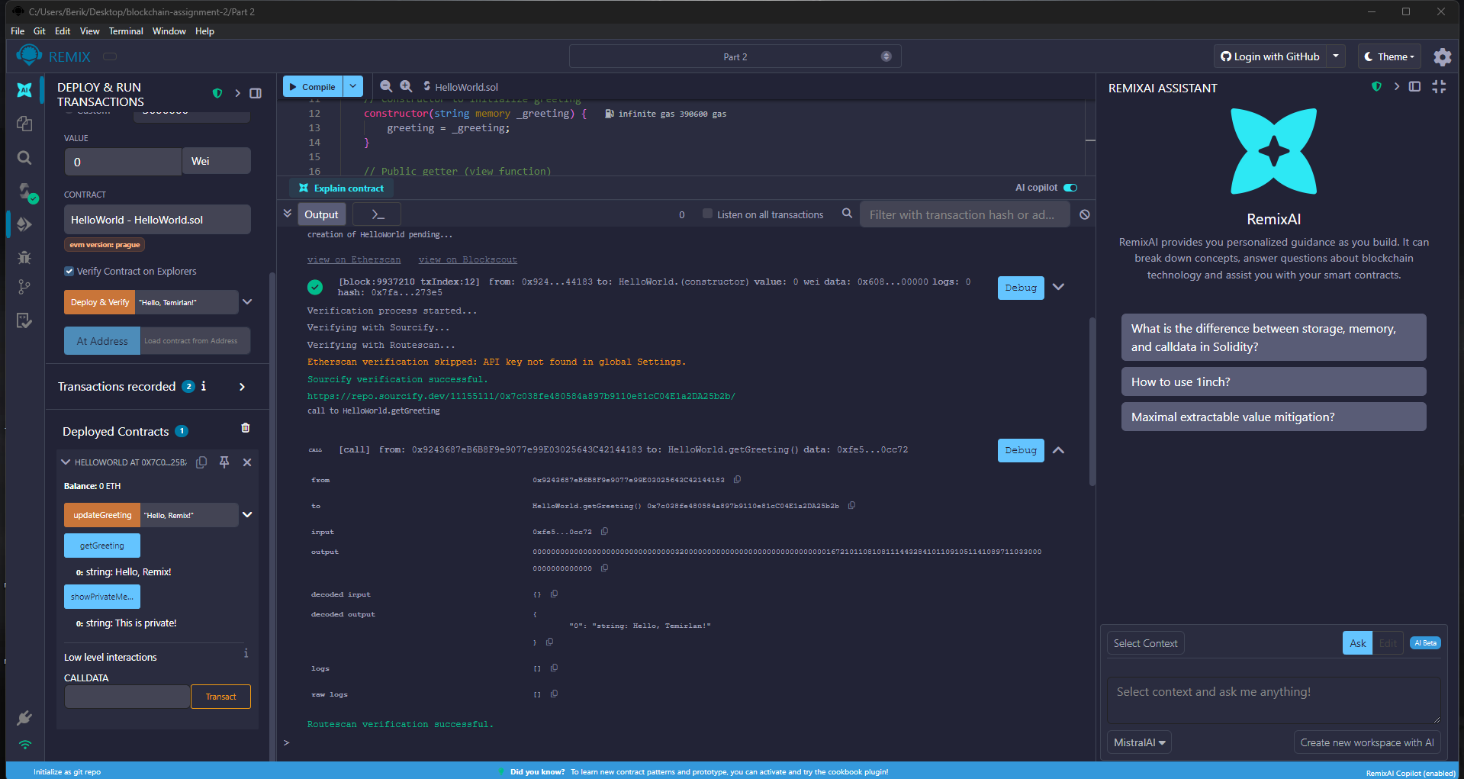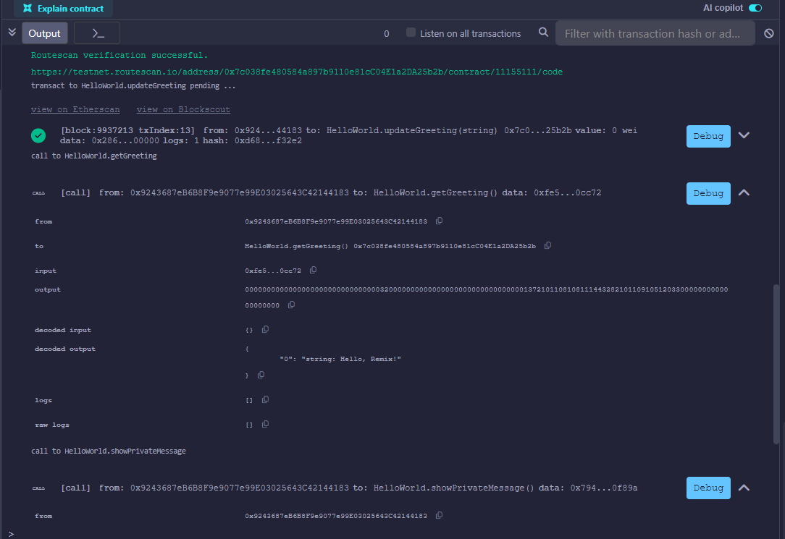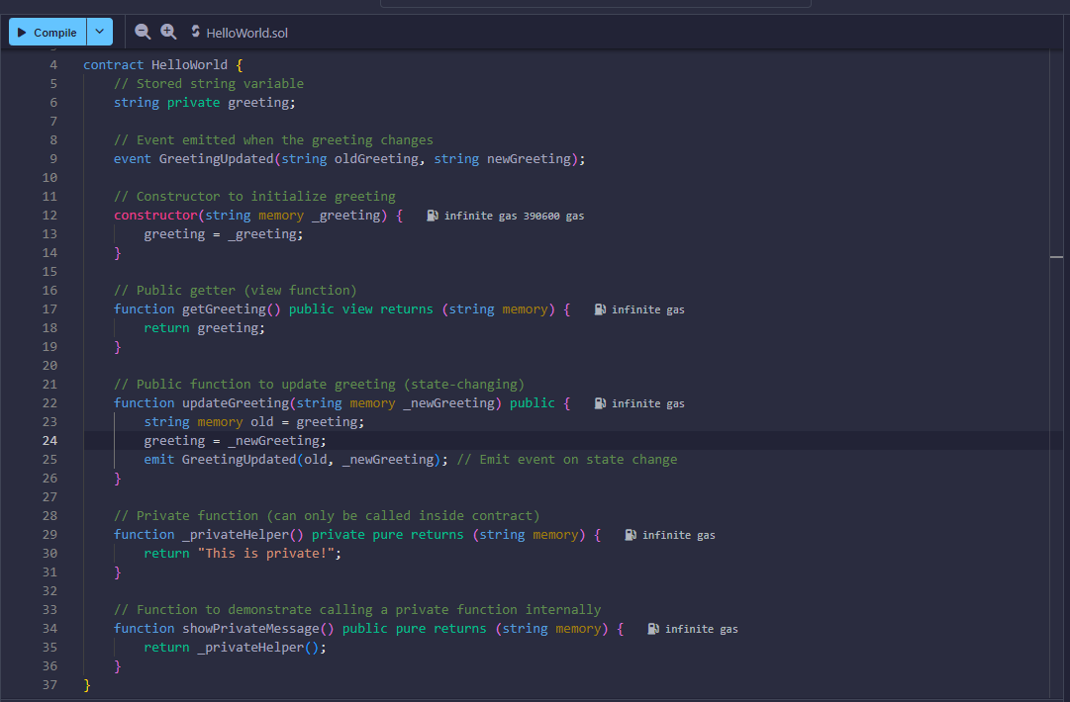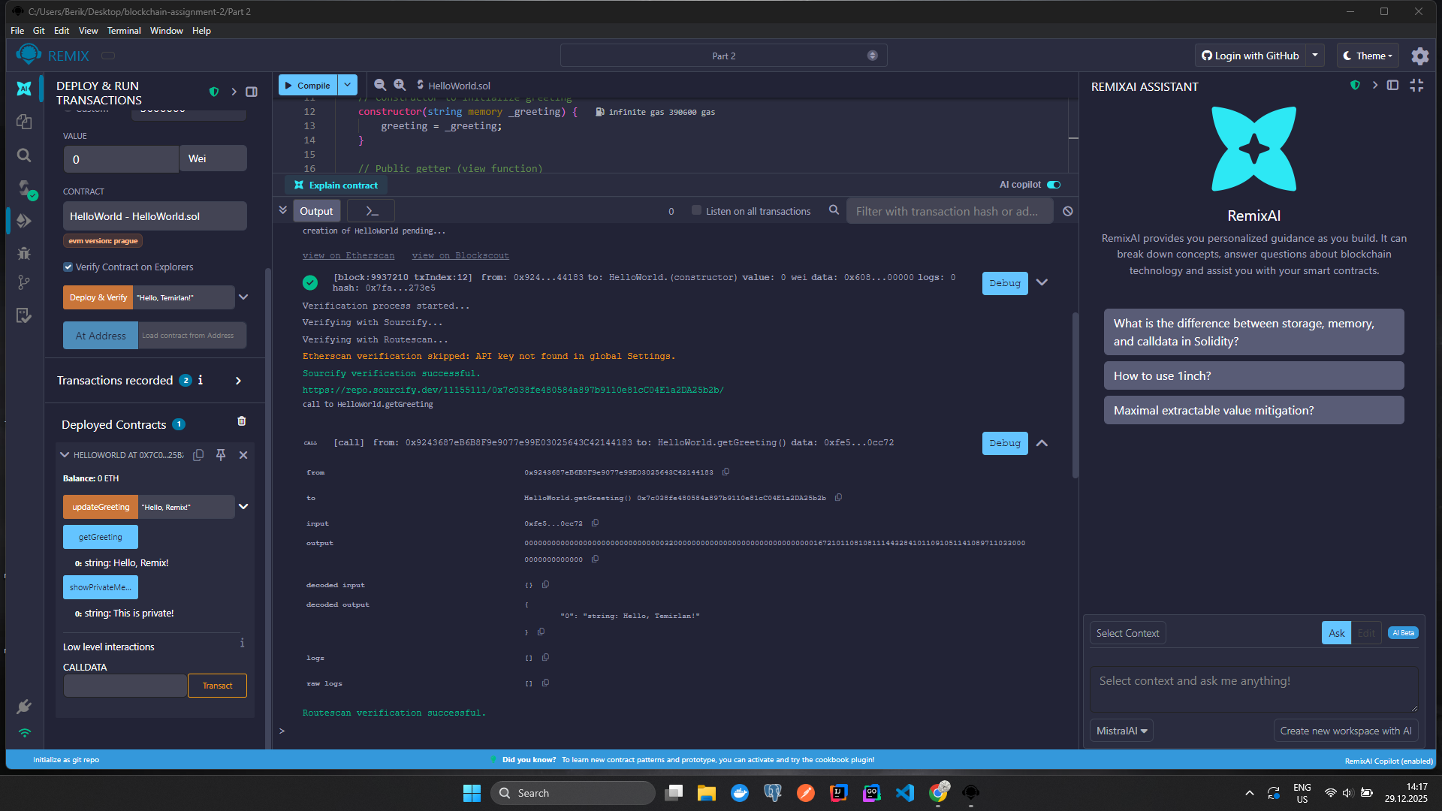
PART B
Experiment 1 — Memory vs Storage Mutation
Contract Code:
(See MemoryVsStorage.sol in Part 2 Folder)
Demonstrate:
modifyViaMemory() – public
modifyViaStorage() – public
State behavior:
The contract initializes a dynamic array in storage.
When the array is copied into a memory variable and modified, the original storage array remains unchanged.
Example:
Initial value: numbers[0] = 1
After calling modifyViaMemory(), numbers[0] is still 1
After calling modifyViaStorage(), numbers[0] becomes 999
Explanation:
When a storage array is assigned to a memory variable, its contents are copied into memory.
Changes made to memory do not persist because memory is cleared after execution.
Bytecode-level explanation:
Storage is read using SLOAD
Data is copied into memory using MSTORE
No SSTORE opcode is executed, so storage is not updated

Experiment 2 — Function Visibility Impact
Contract Code:
(See Experiment2_FunctionVisibility.sol in Part 2 Folder)
Demonstrate:
publicFunc() – public
externalFunc() – external
internalFunc() – internal
privateFunc() – private
Function call behavior:
publicFunc() can be called internally and externally
externalFunc() can only be called externally or internally using this
internalFunc() can only be called inside the contract or derived contracts
privateFunc() can only be called inside the same contract
Explanation:
Public and external functions are part of the ABI and use message calls.
Internal and private functions are compiled into direct jumps and are not accessible externally.

Experiment 3 — Constructor State Initialization
Contract Code:
(See Experiment3_ConstructorLayout.sol in Part 2 Folder)
Demonstrate:
Constructor arguments _a and _b
State variables a, b, and owner
State initialization:
The constructor sets the initial values of state variables at deployment.
Example:
Deployment 1: constructor(10, 20) → a = 10, b = 20
Deployment 2: constructor(999, 1) → a = 999, b = 1
Storage layout:
The storage slot positions remain the same across deployments, while the stored values differ.
Explanation:
Storage layout is determined at compile time.
Constructor arguments only affect the initial stored values, not the storage structure.
Submissions:
